Introducing CUmakeit

**Clemson University Capstone Team Releases Innovative Software for the Clemson Makerspace**

*Now Users can Sign in With the Tap of an ID, and Employees are Able to View Important Data in Seconds*

With CUmakeit, Clemson Makerspace employees can now manage their locations with a single system by allowing them to see vital data and statistics with ease, while also allowing Clemson Makerspace users to seamlessly go from signing in to working on their projects. As a valuable asset to over 800 Clemson students every semester, the Clemson Makerspace is a student-run organization which fosters innovation and creativity by providing high-tech equipment such as 3D printers and laser cutters for Clemson students to use for their school or personal projects.

With the introduction of CUmakeit, it is now possible for employees to access machine and user data, view user credentials, manage machines, and generate reports in a single system. This was previously made difficult by having to consolidate data from multiple third-party systems, and now the process has been cut from five steps to one. No longer do employees of the Clemson Makerspace have to manually enter data into spreadsheets to collect their data, as CUmakeit automates this process with a report generator, which accesses real-time data from the new centralized database. This not only makes management of the space simpler for the Clemson Makerspace employees, but allows for fast and easy data collection for the Clemson Makerspace’s funding proposals—their main source of income. Along with being able to see the data with the click of a button, they now have access to relevant data they were not tracking before, making their proposals even stronger.

Yan-Jing Ni, President of the Clemson Makerspace, says “With the new administrative dashboard introduced by CUmakeit, our jobs have never been easier as employees. The different pages on the dashboard let me see exactly what I need to see at any given point, whether it be seeing who is currently in the space and what certifications they have, or to see how long a print will take on any given printer! It used to take hours to compile and view all of our data in one place, but now we have instant access to the real-time data, which allows us to make real-time decisions. Now, our employees of any technical background are capable of finding what they need.”

CUmakeit also provides improvements to the Clemson Makerspace’s user experience. The old system had consistency problems, where it was confusing for students to sign into the space. Users had to manually enter their username, whereas other places on campus require a simple swipe or tap of our Clemson University ID card. Print logs were often missed because it required students to visit another station and manually input print information, and the only way to see what machines were available was in person or through the registration page. These problems not only made the space less efficient, but also resulted in a lot of key information about print jobs and material usage being lost.

CUmakeit introduces multiple new technologies in order to solve the users’ problems. To speed up the sign-in process, a CUID scanner was placed at the sign-in station, so students can now sign in with the tap of their ID. The need for students to manually enter information into the print logs has been eliminated, as this has been automated so that no valuable information will be omitted from the logs. The new user dashboard displays the user’s certifications, previous print jobs, and available machines, all in one place.

“As a student who frequents the Makerspace, the new system has really made things easier. The CUID scanner makes it quick and easy to sign in, and as soon as I walked in the employees knew who I was and what my certifications are. I like that the new user app allows me to see my previous prints and certifications in one place. I used to have to manually log everything I was going to print, but now that is automated and it saves me so much time,“ says Amy Lin, a mechanical engineering major at Clemson who often uses the 3D Printers for school projects.

Come see how CUmakeit improved the Makerspace today at the Watt Center or at Cooper Library! Contact them and start your Clemson Makerspace training at the following link: <https://www.clemson.edu/centers-institutes/watt/about/makerspace.html>.

Internal FAQ

1. What can be accomplished within the first semester?
   1. We plan on incorporating the various systems that the Makerspace uses into one centralized database and having an administrative dashboard for employees to interact with. We are focusing on the administrative side of the project for the first semester. Further semesters may focus on the user dashboard or different parts of the system.
   2. We have included a schedule at the end of the document which provides a week-by-week overview of how we plan on spending the development process for the first semester.
2. What kind of systems are you incorporating?
   1. Currently the Clemson Makerspace uses 5 different systems - OctoPrint, Canvas, SuperSaaS, Excel, and a separate SQL Database. OctoPrint is an application which keeps track of data relating to the printers themselves—examples including the temperature and status of the machine, what file is being printed, etc. SuperSaaS is a scheduling service which the Clemson Makerspace uses to keep track of reservations for their machines, mainly the laser cutters. Canvas is the main system that is used to initiate training and grant access into the Clemson Makerspace, as users have to complete Canvas quizzes that test them on their understanding of safety and protocols in space. Anyone who uses the Clemson Makerspace should have completed the quizzes and received proper certifications in Canvas. Excel contains additional data that the employees and users manually log, including things such as student information and what they are printing. In the first semester, we want to focus on eliminating the current SQL database that the Clemson Makerspace uses and porting over the data from that database into ours. Within our database, we will include important information from Canvas, OctoPrint, and the Excel spreadsheets. Our plan is to figure out what information from each of these systems is most vital to the employees, and include those into our database. As of right now, SuperSaaS is out of scope for the first semester of development, but may be considered for future semesters.
3. Will the system support updates and plugins?
   1. We are not planning on supporting any other outside plugins at the moment, but may be open to considering it in the future. We do plan on updating the software as needed in future semesters through fixing any bugs or errors, as well as implementing new requested features and anything that we were unable to implement in the first semester.
4. How is the new database implemented?
   1. The relational database is implemented using the RDS service in Amazon Web Services. This provides high availability, scalability, security, and (with our documentation of our system) is easily understood and modifiable by any Makerspace DB admin.
5. What will you be tracking within the database?
   1. Our database will be developed throughout the development process. To see a brief overview of what kind of information we plan on tracking, see Question 2. We will be tracking information already in the SQL database that is in use, but also incorporating data from other systems. We are also planning on tracking data that is not currently tracked anywhere in the systems, such as how much time someone has spent in the space.
6. How can the system accommodate expansion of the Makerspace into more locations?
   1. The current system tracks each location and machine as an individual IP address. Our solution proposes assigning an identifier to the IP address which can distinguish between locations. With this, new locations/machines will just be assigned an identifier to distinguish them from current locations/machines.
7. How can the system accommodate new machines?
   1. Employees of the Makerspace will also be able to add/remove machines which will automatically be assigned a unique identifier.
8. What other systems were not incorporated?
   1. The only system that was not incorporated was SuperSAAS, software that The Clemson Makerspace uses for reservations. This system should be incorporated into the future because SuperSAAS does not allow for reservation of specific machines, but rather an indication as to when someone will be coming into one of the spaces.
9. What other systems would we like to put in place?
   1. We would like to put a system in place to predict when machines will fail based on their energy consumption, which can be gathered from Octoprint. We would plan on using a linear regression model in Amazon Sagemaker.
   2. We would like to develop a system that will be able to track users with more precision. Currently, it is only known when a user enters the space, but it would be very helpful to know when the user leaves the space, what machines or tools they used in the space, whether they were there for school or personal projects etc.
10. What kind of information is included in print logs?
    1. The following article from Octoprint describes what kind of information the print logs include, as well as how to find them on the machines. <https://community.octoprint.org/t/where-can-i-find-octoprints-and-octopis-log-files/299>
11. What will you be tracking within the database?
    1. We will be tracking information already in the SQL database that is in use, but also incorporating data from other systems. We are also planning on tracking data that is not currently tracked anywhere in the systems such as including how long someone is in the space, what they were using, and for how long.
12. What does the timeline for this project look like?
    1. We have a very rough, tentative schedule below with color coding.
       1. Everyone
       2. Front-end
       3. Back-end

|  |  |
| --- | --- |
| Dates | Goal |
| 2/4 - 2/10 | Finish project planning, finish front-end and back-end design, research various technologies, set up EC2 instance, have framework designed for a simple html web page/app. |
| 2/11-2/17 | Write scripts to populate database with existing data, write scripts to calculate information relevant for proposals(total spool weight, total print hours, % of successful prints), create html for two - initial dashboard page and user data. |
| 2/18 - 2/24 | Write scripts to populate database with Octoprint and Canvas, create html for two/three pages - printer information and current users. |
| 2/25 - 3/2 | Write scripts to pull relevant information from db to front-end, fill db with dummy information, create html for two/three pages - download report and overview. |
| 3/3 - 3/9 | Connect front-end with back-end, write scripts to allow new machines and locations to be added to the db, as well as removed from, javascript to add functionality to pages - which pages depend on progress of db integration. |
| 3/10 - 3/16 | Test connection with user feedback, write scripts to update db with real-time data, research how to incorporate scanners and printer data, add javascript to more pages - which pages depend on progress of db integration. |
| Spring Break |  |
| 3/24 - 3/30 | Implement scanners for login and on printers(??) and laser cutters(??) and connect to db, implement additional features based on user feedback |
| 3/31 - 4/6 | Display real-time info on users in the space and printers being used  Implement scanners for login and on printers(??) and laser cutters(??) and connect to db, css design part 1 |
| 4/7 - 4/13 | ~~Fill database with real information~~, css design part 2 |
| 4/14 - 4/20 | Test with real data, update based on testing, any last minute bug fixes or feedback taken into account and worked on |
| 4/21 --- | Final presentation |

External FAQ

1. What will the Administrative Dashboard Look Like?
2. Below are some preliminary sketches of how we envision the dashboard to look, but these are subject to change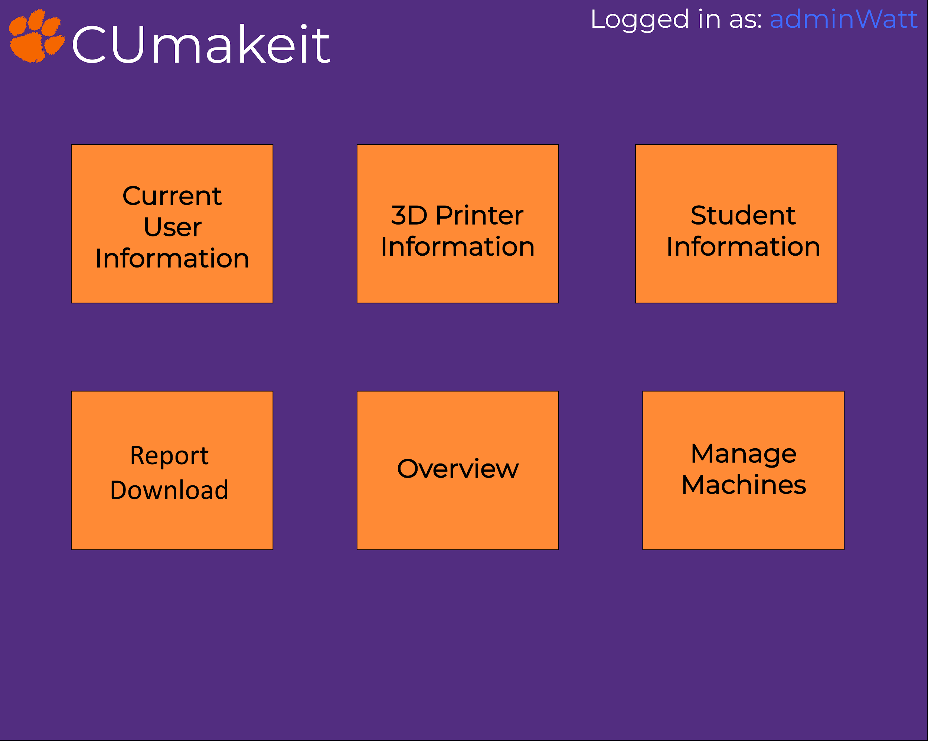

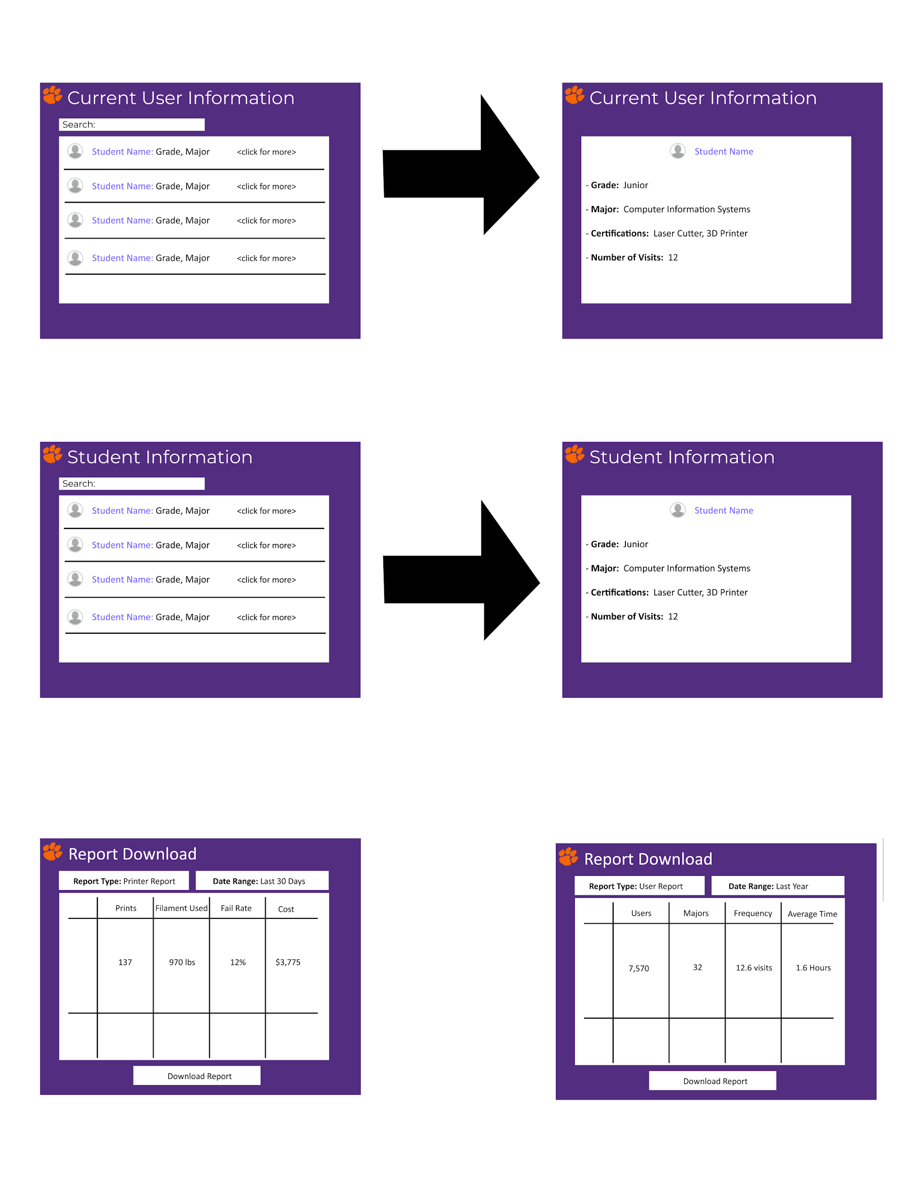

2. Why is this technology useful?

1. Our technology ensures that the Clemson Makerspace receives the correct amount of funding every semester. This trickles down to students and faculty that use the space, as they will be able to create any product they desire without worrying about the Clemson Makerspace running out of material or not having enough printers to meet demand. This will also help with the expansion of the space, whether that be additional locations, or additional machinery.

3. What is novel about this implementation?

1. Employees of the Clemson Makerspace are now able to view all of the data that they previously had scattered across multiple systems, into one system. At the click of the button, a report will be generated that they can use for funding proposals. This saves them lots of time as previously it took a week to collect all of the data they needed for funding proposals. Additionally, employees on the clock will be able to manage the space more efficiently because we have included all of the certifications from Canvas into our system.